**CIEI INTERNSHIP , [Date: 25th Mar ,2022]**

**“AI MODULATED SMG(SMART - MEDICO - GLASSES)”**

**BACKGROUND**

* **Artificial intelligence is the ability of machines to perform certain tasks, which need the intelligence showcased by humans and animals. This definition is often ascribed to Marvin Minsky and John McCarthy from the 1950s, who were also known as the fathers of the field.**

**As we know,Artificial intelligence allows machines to understand and achieve specific goals. AI includes machine learning via deep learning. The former refers to machines automatically learning from existing data without being assisted by human beings. Deep learning allows the machine to absorb huge amounts of unstructured data such as text, images, and audio.**

**In 2011, the first smart glasses were created by Google.**

**Smart glasses or smart glasses are**[**wearable computer**](https://en.wikipedia.org/wiki/Wearable_computer)[**glasses**](https://en.wikipedia.org/wiki/Glasses)**that add information alongside, that are able to change their optical properties at runtime. Smart sunglasses which are programmed to change tint by electronic means are an example of the latter type of smart glasses.**

**Smart Glass technology is not new but using it in medical field and healthcare is really much innovative. The vision behind Google glass which was launched in 2011 was brilliant,but the product was a failure. There were issues related to health and safety, price, battery, heat generalization, language, privacy, and many more. Google Glass did not provide the augmented reality experience that was expected by customers. Instead, it was more of an extra screen displaying notifications, weather, etc.  
So basically, the recent innovative technology used is now the base of a set of glasses designed to assist the blind. Known as Envision Glasses, they utilize AI to verbally tell their wearer what they're looking at.**

**And recently,announced in their *newest* form this week at the CSUN Assistive Technology Conference, Envision Glasses are initially paired with an iOS/Android smartphone app when being set up, but function**

**independently (for the most part) from that point on. Their software runs on a Qualcomm Quad Core processor, within Google Glass Enterprise Edition 2 hardware.So, Its really a great and very innovative approach of use of AI empowering HEALTH AND medical tools and making it much efficient.**

**Like we already had Smart sunglasses which are able to change their light filtering properties at runtime generally use liquid crystal technology. As lighting conditions change, for example when the user goes from indoors to outdoors, the brightness ratio also changes and can cause undesirable vision impairment. An attractive solution for overcoming this issue is to incorporate dimming filters into smart sunglasses which control the amount of ambient light reaching the eye. An innovative liquid crystal based component for use in the lenses of smart sunglasses is PolarView by LC-Tec. PolarView offers analog dimming control, with the level of dimming being adjusted by an applied drive voltage.**

**Another type of smart sunglasses uses adaptive polarization filtering (ADF). ADF-type smart sunglasses can change their polarization filtering characteristics at runtime. For example, ADF-type smart sunglasses can change from horizontal polarization filtering to vertical polarization filtering at the touch of a button.**

**Experts believe smart glasses will soon outpace VR headsets in terms of adoption and use.This new generation of smart glasses will infuse Al together with AR to give users a new and better perspective.Smart glasses with earphones and mics are a thing of the past. Experts believe the next generation of intelligent eyewear will use Artificial Intelligence (Al) and Augmented Reality (AR) to turn on the smarts.**

**SUMMARY**

**The basic idea and thought is to empower medical and healthcare facilities with AI power to have effivient and desired result and pleased user and conumers. The idea of AI MODULATED SMG (Smart Medico Glasses) is that the glasses would have same functionality as a smartphone but ofcourse operated and modulated with advanced technology and AI functionalities.**

**Wearing these glasses will enable user to see medical things from a prototype.And seeing and monitoring the details of the part we are seeing through glasses.Another idea is already in use of these glasses is to helpvisually impaired people .**

**The idea in envision used is that whenever the user needs to know what's in front of them,or what part they want information or detailes they start by finger-swiping the right-hand arm of the glasses to select a mode, guided by synthetic speech feedback from the integrated speaker. Once a mode has been selected, the user double-taps the arm to record an image, which is processed by the system's AI-based algorithms.**

**Unlike the completely immersive virtual reality (VR) headsets, smart glasses or can say now smart-medo-glasses(SMG) give users a sense of physical and digital worlds simultaneously, providing a much more natural experience. This is why many companies, including Google, Apple, Meta, are investing in the research and development of the next generation of smart eyewear that'll provide a superior augmented reality experience especially in health and medical treatment feilds.**

**Smart Glasses even opening a new door to many new healthcare applications, especially with the prevalence of telemedicine, which can be aided with the help of Al enhanced smart glasses for conducting diagnostics remotely and the technology can also assist safety inspections with specially trained Al models that aid users by overlaying any relevant information, such as identifying defects, through the mixed reality glasses and low vision users, smart glasses could have multiple uses in technology and science, allowing users to magnify objects on the fly, identify objects as they come into view, or even instruct users as they perform their tasks.**

**DISCRIPTION**

**Basic science used behind smart glasses** **: -** **It all works because of polymer dispersed liquid crystals and the film made up of plastic polymer with really tiny holes about 0.323 microns.These tiny hole are filled with liquid crystals sandwiched between two conductive layers so when theres no current flowing through liquid crystals,are randomly oriented inside and they scatter light pass through this making it look opaque,although when occurance runs through it all the liquid crystals align in the same direction and this allows light to pass through unscattered.The liquid crystals are autotrophic.Liquid crystals are lined up with the current their index of refraction in that orientation matches the polymer.**

**AI ,ML with AR Technology use in these glasses and designing :-** **Smart glasses are provided comprising a bridge, rims, the rims comprising corrective lenses, temples connected to end pieces, a printed circuit board, memory. battery, camera, microphone, bone conduction speakers, connectivity module, cellular communications unit and hardware, and artificial intelligence interface in electronic communication, the connectivity module and the cellular communications unit and hardware configured and programmed to pair or connect the smartglasses to a smart phone or smartwatch, the smartglasses configured and pro grammed to receive oral requests or commands at the microphone and artificial intelligence interface to perform mobile device tasks or applications and process and communicate the oral requests or commands to a mobile device application controlling paired or connected devices used for display or presentation of information related to the requested or commanded tasks or applications, the mobile device application controlling paired or connected devices 3 used for display or presentation of information related to requested or commanded tasks or applications, configured and programmed to display or present information related to the requested or commanded tasks or applications on the smartglasses, a paired or connected smartwatch or paired or connected smartphone or monitor or any large screen based on default settings.**

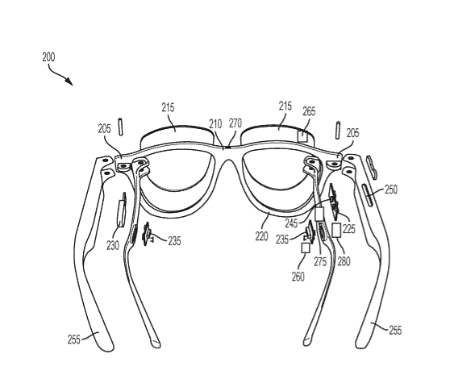

**Above figure depicts smart glasses that can be used in accordance with the methods and systems for using artificial intelligence to enhance experiencing augmented reality s information described herein. The smartglasses 200 can have a bridge 210 with end pieces 205 connected to temples 255 and corrective lenses 215 in rims 220. The temples 255 include a microphone 225, battery 230, bone conduction speakers 235, printed circuit board 245, control pad 250, connectivity module and hardware 260, camera 265, and USB connection 270, and cellular communications unit and hardware 275, which enables the smartglasses 200 to com municate over the cellular wireless network, and smart glasses Al interface 280, all of which are electronically connected.**

**The connectivity module and hardware 260 may use WiFi, Bluetooth, near field communication, and/or other types of wireless technology standards to pair and/or com municate with other mobile devices, including smartphones and smartwatches, such as smartwatch 300 and smartphone 20 400. Other components not depicted could also be included in the above smartglasses .**

**Improving productivity of clinicians .There is an effort required by clinicians to manually enter patient data into EMR systems. This has partly contributed to the low adoption of EMR in the country. Smart glasses can improve productivity by automating the capture and storing of patient data into EMR systems. For the digital transformation to succeed , the PHR/EHRs must be updated with patient data during outpatient and inpatient care. Outpatient care would include consultations with general physicians or specialists with an independent practice.These clinicians may perceive the manual entry of patient data into the respective PHR/EHRs as a wasteful activity. Smart glass can help in this regard by automating the data entry process.  
Diagnosis and treatment of a patient from a distance mean improved access to quality care, reduced costs and wait times for patients, and a reduced risk for healthcare providers. There are several potential applications of smart glasses in telehealth.  
  
No need of watching monitor in medical staff’s movement leads to decreasing in number of monitor installation.It would help to create smart and pratical environment in crowded OR.Image converting to 3D is also available on smart glasses.Increasing efficiency of medical staff.**

**Smart Glasses would help for instance ,link a hospital wound and with specialist with a home care taker in the patients living room The specialist could observe and discuss treatment,draw images live on screen if anything needs to be explained and immediately add progress reports including photos to the pateinet s report.Platform is secure,has all the necessary certificates.Speedup recovery.**

**Some of the made smart glasses are :**

[**Lenovo ThinkReality A6**](https://techtoday.lenovo.com/us/en/solutions/thinkreality)**:- The ThinkReality A6 AR headset includes inside-out 6DoF tracking to optimize AR experiences and enable industrial versatility. This mobile device is designed to help the workforce use AR applications to receive expert assistance, reduce repair times, decrease errors, streamline complex workflows, improve training quality, and save costs. The device is powered by [Wikitude](https://www.wikitude.com/presscorner/press-release-wikitude-x-lenovo-think-reality/" \t "_blank) image and object recognition technology.**

[**Vuzix M300**](https://www.vuzix.com/products/m300xl-smart-glasses)**:-These smart glasses provide an agile workplace, with fully connected staff and managers. Industry operations are facilitated by the wide range of apps available, a built-in HD camera, AMLCD display, and more.**

**The HoloLens is an untethered mixed reality device that is designed to deliver value instantly. Users get the benefits of using cloud and AI services from Microsoft—including reliability, security, and scalability.Being one of the leading mixed reality headset devices on the market, Wikitude has optimized its**[**augmented reality SDK**](https://www.wikitude.com/download-wikitude-sdk-for-hololens/)**to support and complement the Microsoft HoloLens 1.**

**This experience is achieved through either an Optical Head-Mounted Display (OHMD), Augmented Reality (AR) technology, or through Heads Up Display Glasses (HUD).**

**A Real life example of use of Smart Glasses in health treatment :Liliane,midwive in the central health center of Sondji,DRC from where main hospital is too fat.The nearest district hospital is located in Kingandu at 9km distance.Lillian uses the Iristick.Z1 smart glass when she needs help from doctor in the district in Kangandu the expert can see the patient and command accordingly to Liliane(nurse),the camera in glasses helps real time video communication in efficient and short period of time.Theres many more examples where these glasses hav been proven very efficient way of treatment in medical like Google smart glasses in Indiana and South Korea.**

**These Smart glasses producers have realized that to reach mass-market usage, they must first overcome the challenge of balancing functionality and wearability at an affordable cost.Technologies will improve more in the coming years and so as challenges to face but ofcourse we can minimize those and especially in healthcare precautions preventions and maintainance will be kept.**

**Coming to technology part what we will be using as mentioned above and we will use advanced enough technologies in coming years and more powered like AI and Machine learning and all wecan make through it with help of these technologies.**

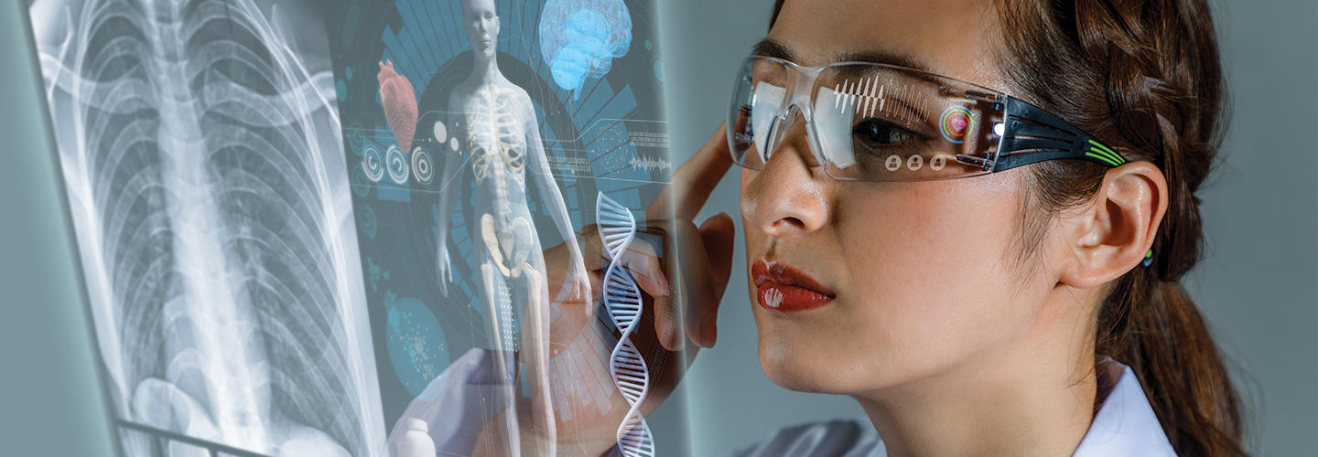

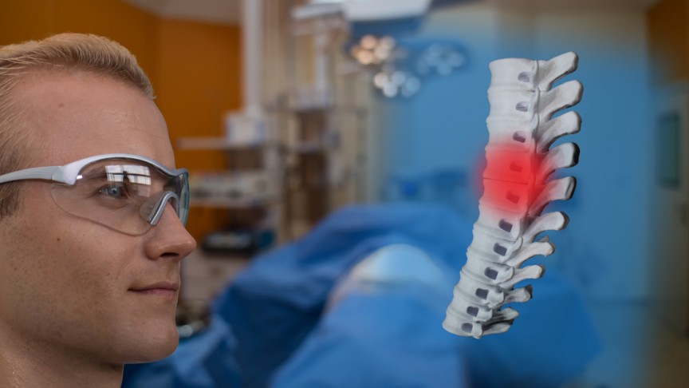

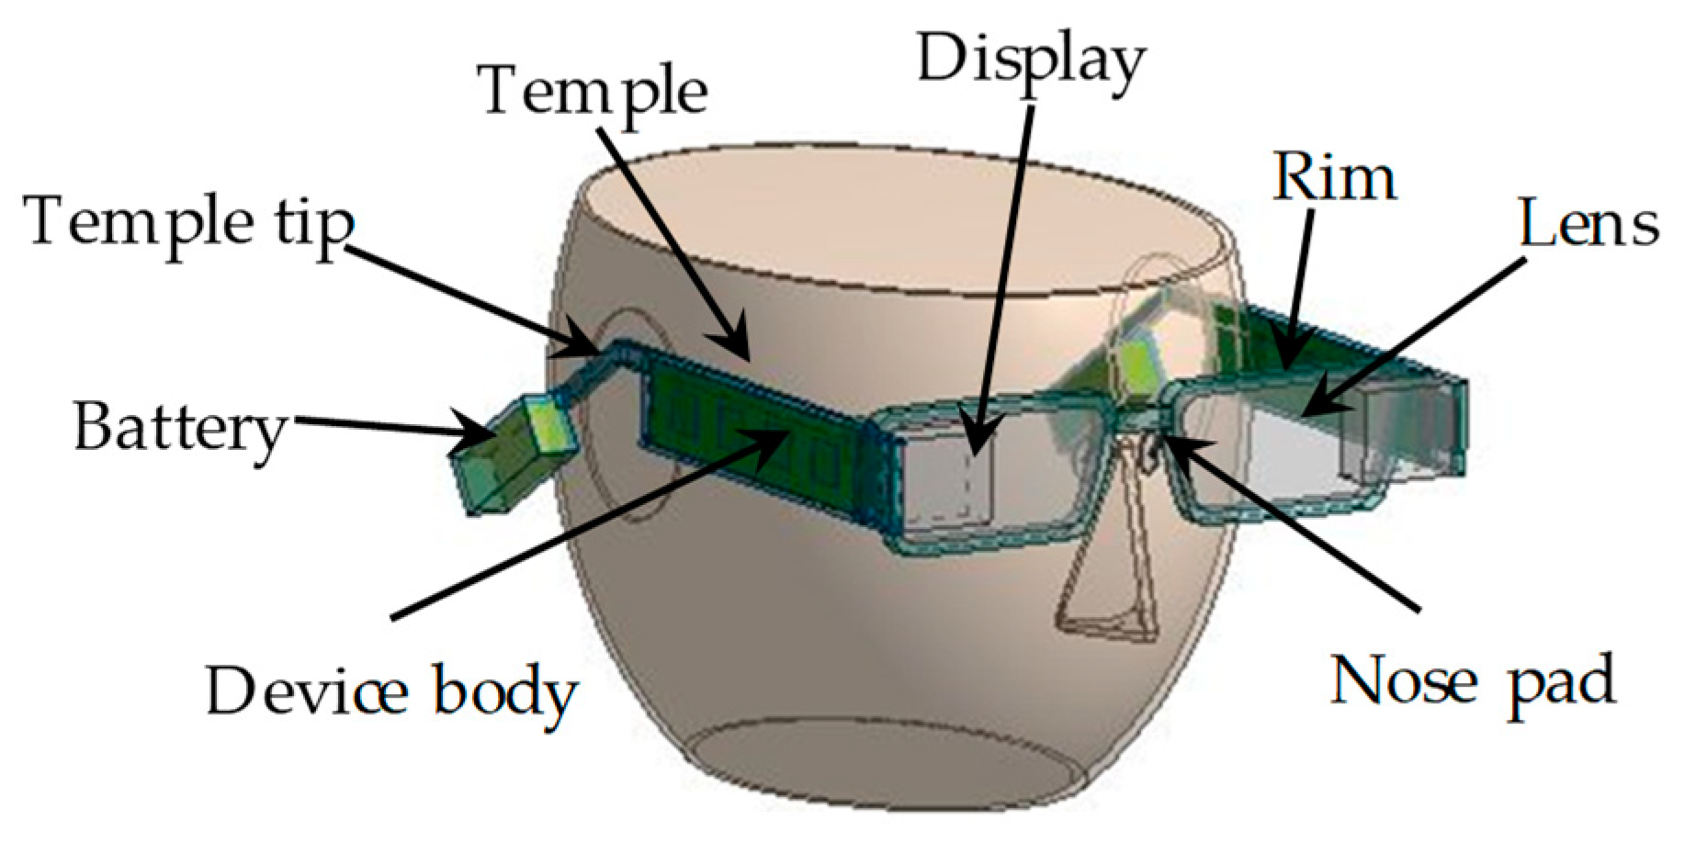

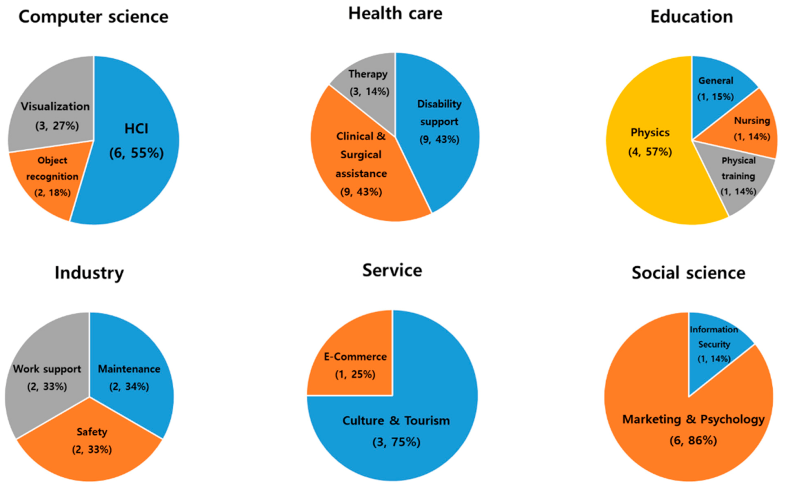

**-BHAVNA MOGHA**

**BSC. (HONS.) COMPUTER SCIENCE (2nd Year) Student at**

**SHAHEED RAJGURU COLLEGE OF APPLIED SCIENCES FOR WOMEN, DELHI UNIVERSITY,NEW DELHI.**